MODEL QUESTION PAPER EN09 107 BASICS OF ELECTRICAL, ELECTRONICS AND COMMUNICATION ENGINEERING
Time: 3Hrs Maximum: 70Marks

Section 1(Basics of Electrical Engineering)
Part A
Answer any All questions

- Define Magneto Motive Force (2Marks)
- What are the advantages and disadvantages of induction motor (2Marks)
- A resistance of 10 Ω,an inductance of of 0.14H and a capacitor of 100μF are
Connected in series across a 100V, 50Hz supply. Calculate the impedance. (1Mark)

Part B

Answer any two questions

- Using Kirchhoff’s law, find the current through 10 Ω resistor.

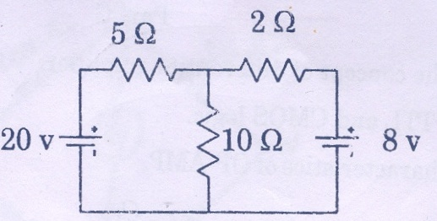

- Derive the EMF equation of a dc generator
- Calculate the active and reactive components of current in each phase of a star connected, 5000V,3-Phase alternator supplying 3000kW at a power factor of 0.8.
(2X5 = 10Marks)

PartC
Answer All questions
7(a) (i) State and Explain Faraday’s laws of electromagnetic induction (5 marks)
(ii)Compare Electric and Magnetic Circuits (5 Marks)

Or
(b) (i) Explain the following terms:-
- Frequency (2) Average Value (3)Power factor (6Marks)
(ii)A resistance o 10 Ω is connected in series with an inductance of 0.05H and a capacitance of 300μF to a 100V supply. Calculate the value and phase angle of the current when the frequency is 50Hz.
(4Marks)

8 (a) (i) Explain the constructional details of dc generator (5Marks)
(ii) Explain the principle of operation of induction motor (5marks)
Or
(b) Explain the construction and principle of operation of single phase transformer (10Marks)

