Sahrdaya College Of Engineering And Technology
Combined I&II Semester B.Tech Degree Model Examination 2012-13
EN 09 105 Engineering Mechanics
Time: 3 hours (Common to all branches) Total Marks:70

Part A
Answer all questions.
Each question carries 2 marks
- State parallelogram law of forces.
- What are the equations of equilibrium for a system of concurrent forces in a plane?
- Define static friction.
- State Perpendicular axis theorem.
- State equations of motion for translation.
(5x2 =10 marks)

Part B
Answer any four questions.
Each question carries 5 marks
- A ball Q of weight 12N rests in a right- angled trough as shown in figure 1. Determine the forces exerted on the sides of the trough at D and B if all surfaces are perfectly smooth.
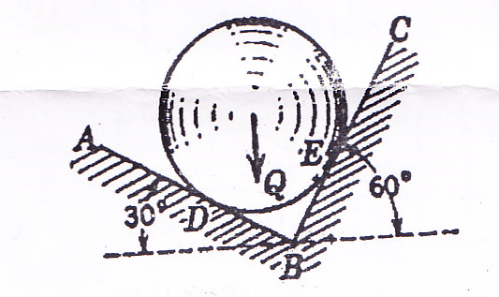
Fig. 1
- Find the frictional force for the block shown in figure 2 and state whether the block is in equilibrium or in motion. Also determine the additional force P that must be added to 140N force, to just move the block to the left.

Turn over
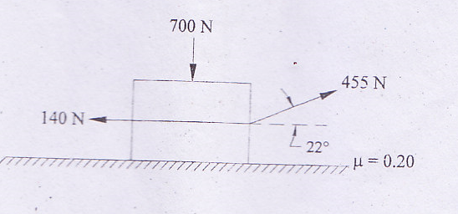
Fig. 2
- Determine the moment of inertia of solid cylinder of radius R and length L about an axis passing through the centre of gravity G and perpendicular to the axis of cylinder.
- A bomb is released from an aeroplane, flying at a speed of 1500 km/hr on a straight line, 2000m above the ground. Determine the time required for the bomb to reach the ground and the horizontal distance travelled by the bomb.
- A railway wagon of weight 4KN is moving with a velocity of 25m/s. A force of 200 N acts on the wagon for 2 minutes. Calculate the velocity of the wagon, if the direction of the applied forces is (i) in the direction of motion; and (ii) in the opposite direction.
- The 15 kg uniform cylinder having 150mm radius shown in figure 3. is rolled up the 20º incline with an initial speed of 15m/s. Determine the maximum distance that the cylinder will roll up the incline. Assume that no slipping occurs.
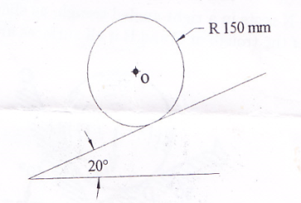
Fig. 3
(4x5 = 20marks)

Part C
Answer section (a) or section (b) of each question
Each question carries 10 marks
- Two vertical masts AB and CD are guyed by the wires BF and DG, in the same vertical plane and connected by a cable BD of length l = 20m, from the middle point E of which is suspended a load Q of 100N as shown in fig 4. Find the tensile force S in each of the two guy wires BF and DG if the sag d = 1m.
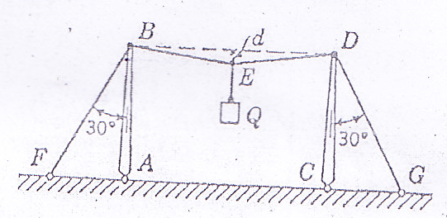
Fig. 4
OR
- Two smooth circular cylinders, each of weight W = 100N and radius r= 60mm, are connected at their centres by a string AB of length l= 160mm and rest upon a horizontal plane, supporting above them a third cylinder of weight Q= 200N and radius r = 60 mm. as shown in figure 5. Find the force in the string AB and the pressures produced on the floor at the points of contact D and E.
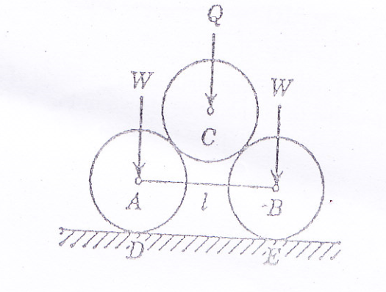
Fig.5
- Find the moment of inertia about the centroidal axes for the section shown in figure 6.
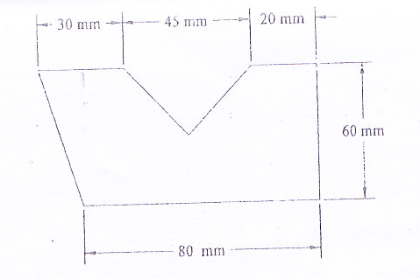
Fig . 6
OR
- A cantilever truss supported on rollers at E and hinged at A is loaded as shown in figure 7. Determine the reactions at A and E.
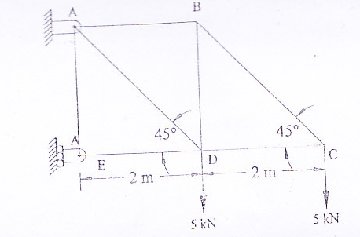
Fig. 7

- Two weights P (40N) and Q ( 30N) are connected in arrangement as shown in figure 8 in next page. Neglecting the friction and the inertia of the pulleys and cord, find the acceleration a of the weight Q. Assume that P= 40N and Q= 30N.
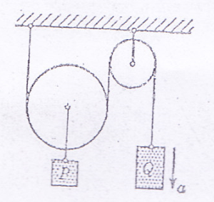
Fig. 8
OR
- A projectile is aimed at a mark on the horizontal plane through the point of projection and falls 12 m. short when the angle of projection is 15º .When it is tried again it over shoots the mark by 24m with the angle of projection as 45º. Find the correct angle of projection to hit the mark.

- A wheel is attached to the shaft of an electric motor of rated speed of 2000 r.p.m. When the power is switched on, the unit attains the rated speed in 10 seconds and when the power is switched off, the unit comes to rest in 100 seconds. Assume uniformly accelerated motion and determine (i) the number of revolutions the unit turns to attains the rated speed; and (ii) to come to rest.
OR
- An elevator is modeled as m1= 2000kg, m2= 1800kg and uniform disk of m3= 200kg as shown in fig 9. Calculate the velocity of m1 at time t= 10sec after the system starts from rest.
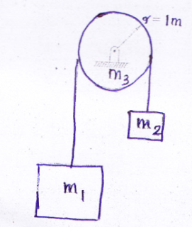
Fig. 9
(4x10=40 marks)

