FAQ’s on Phone-Backup
Procedure for accessing through WAP, WEB & SMS:

PHONE BACK Up THROUGH WAP ( For GPRS Customers) :
1. GPRS has to be activated on the subscriber’s BSNL SIM.
2. The subscriber will click /go to the link : http://pb.bsnl.onmobile.com/bsnlwap/wap
3. The subscriber will be informed that he is charged Rs 30/month for this service.
4. The subscriber will download the client binary on to his mobile phone.
5. The subscriber will access the downloaded application.
6. The subscriber will be given the following options for backup,
a. Backup – he can take back up of contacts, tasks, photos, events etc.
b. Schedule – He can schedule the backup tasks on daily, weekly or Monthly
c. Restore – If you want to restore your backup back to the mobile phone.
7. The subscriber can choose any of the above option & start accessing.
8. The subscription fee for this is Rs 30/month.
PHONE BACK Up THROUGH SMS (58989):
1. To activate this service, the subscriber will sms <SUB> to 58989 ----- to subscribe for the Phone backup service
2. The subscriber will receive an MT sms informing him that he has been charged Rs 30/month.
3. The phone back up subscriber can start backing up contacts by smsing <ADD> <NAME> <NUMBER> to 58989 (e.g.: ADD Rishit 9820244242, Jayeesh 9423011316)
RESULT: The contacts will be added on to the phone backup server and displayed on WEB.
4. If the subscriber wants to restore a single contact, he should sms <GET> <NAME> to 58989 (eg: Suppose the subscriber have deleted contact name “Jayeesh” from handset and this contact was already backed up on server then perform: GET Jayeesh)
RESULT: The contact should be restored on handset.
5. If the subscriber wants to restore all the contact, he will sms <RESTORE> <NAME> to 58989 (eg: Suppose a Subscriber has lost his handset & has bought a new phone with the same SIM number) RESULT: The contact should be restored on to the handset.
6. If the subscriber wanted to deactivate this service he can sms <UNSUB> to 58989. He will get deactivated immediately.
7. If the subscriber wants to delete a contact from the phone backup server he will sms <DELETE> <NAME> to 58989
8. The subscription fee for this is Rs 30/month.

PHONE BACK Up THROUGH WEB:

1. A subscriber can activate the phone backup service through SMS or WAP.
2. He will be sent a user name & password.
3. The phone backup subscriber can access a WEB link using the same user name and password.
4. The subscriber will access to the web link: http://pb.bsnl.onmobile.com/bsnlweb

- What is Mobile Phone Backup?

Mobile Phone Backup is a service that safeguards all data of your mobile phone including Contacts, Calendar, SMS, Photos, Videos and Music. The Mobile Phone Backup service copies your mobile phone’s data in a secure manner to Operators secure Mobile Phone Backup system, and also enables you to restore the saved data on your phone (New / Existing) whenever you change your phone or in case you lose the data accidentally.

- What are the features available on Mobile Phone Backup service?

Mobile Phone Backup service enables you to:
- Easily & quickly backup all your mobile data
- View, manage and edit all your data through secure internet website
- Copy/Restore all your saved/backed-up data to your phone (New or Existing)

- What all kind of data that can be saved using Mobile Phone Backup service?

You can save the following categories of data depending on your phone model:
- Contacts List
- Photos
- Videos
- Music
- Events & Tasks
- SMS

- Can I use Mobile Phone Backup service from any connection, be it pre-paid or post-paid?

Yes you can use Mobile Phone Backup service from your pre-paid as well as your post-paid connection.

- What are the subscription charges?

The charges are Rs.30 per month, on 30 day renewable basis.

- Can I use any phone handset to save/backup my data?

Yes you can use any mobile phone to save/backup your data. Your phone handset model will be categorized in either of the following two categories:

- GPRS capability phones - If you have GPRS phones you can save all your Contacts List, SMS, Photos, Videos and Music. You will use Rich client (Backup Option) or Native SyncML (Synchronize) options for using the Mobile Phone Backup service. (For details, refer to FAQ No. 7)
- Non-GPRS phones – If your phone is a Non-GPRS phone model then you can save your Contacts List only. You will have to save/backup and restore phone data using SMS. (For details, proceed to FAQ No. 25)

- What is GPRS?

GPRS stands for General Packet Radio Service. It is an enhancement to the GSM mobile communications system, which allows internet browsing on a mobile phone as well as connecting to data services.

- If my mobile phone has GPRS capability how do I get GPRS activated on my mobile phone?

Call the Customer Care to get GPRS activated. Customer care will provide you the steps to activate the GPRS. Once GPRS is activated, please select operator specific access point as the default access point.

- How can I register to Mobile Phone Backup service using my GPRS capability phone?

To start, ensure that you have GPRS enabled on your phone. Once GPRS is activated by following steps given in FAQ No. 9, you can register to the Mobile Phone Backup service by any one of the following 2 methods:

- Send SMS ‘SUB’ to short-code 58989 (Toll-free). (For details, proceed to FAQ No. 11)
- Open your mobile phone’s web browser, type Mobile Phone Backup WAP link http://pb.bsnl.onmobile.com/bsnlwap and access the WAP Portal. (For details, proceed to FAQ No. 12)

- How do I download and install the Mobile Phone Backup application on my GPRS phone?

Once you receive the SMS confirming your registration, you will receive an SMS containing a link. Then follow these steps:
- Open the SMS and select / click on the link in the SMS.
- This will redirect you to the WAP page where you need to accept Terms and Conditions and download the application.
- The phone will prompt you to ‘install’ the application on your mobile phone
- You need to select ‘Yes’ to install the application on your mobile phone
- Once installed, Mobile Phone Backup icon will appear in your 'Phone Menu' or 'Games Folder' or 'Application Folder' depending on your phone model
- You will receive a SMS with a link having complete instructions to setup the Phone Backup service settings. (For details, refer to FAQ No. 15 & FAQ No. 19)
- You will also receive a SMS with the Internet URL link of your Phone Backup account, the Account User ID, which is your phone number in 91xxxxxxxxxx format and the password for Web-login. (For details, refer to FAQ No. 31)
- How do I download and install the Mobile Phone Backup application by directly accessing the WAP Portal from my GPRS phone?

If you have directly accessed the WAP Portal by typing http://pb.bsnl.onmobile.com/bsnlwap on your phone’s web browser, then you will be prompted to download the application directly on to your mobile phone and installation will happen automatically. Once installed, Phone Backup icon will appear in your 'Phone Menu' or 'Games Folder' or 'Application Folder' depending on your phone model.

- Will the Mobile Phone Backup application be downloaded on all GPRS phones?

No, all GPRS enabled phones do not support auto-download of the Mobile Phone Backup application. Only if it is a JAVA or Symbian phone handset, the Phone Backup application will be directly downloaded to your mobile phone. To know what type is your handset call customer care xxx(Toll-free)

If your phone is a JAVA or Symbian phone handset then please proceed to FAQ No. 14.

In case your phone is not a JAVA or Symbian phone handset, then you will be sent appropriate SMS with settings for using the mobile phone’s inbuilt SyncML (Synchronize) option to connect to Phone Backup service. (For details, refer to FAQ No.19)

- How do I launch Mobile Phone Backup application on my GPRS (JAVA & Symbian) phone?

Open the folder in which the Mobile Phone Backup application has been saved and click on the Phone Backup icon to launch it. Once launched the Mobile Phone Backup shows a home screen with options like Backup, Schedule, Restore and Settings.

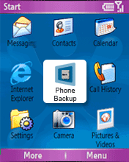
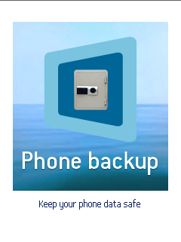
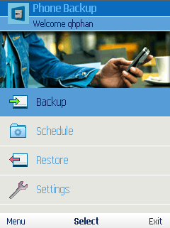

- Are there any other settings that I need to change before using Mobile Phone Backup from my GPRS (JAVA or Symbian) phone?

Yes, you have to ensure that following settings are done for JAVA or Symbian phone handsets as case may be, before attempting to use Mobile Phone Backup service. To know what is your mobile handset type (JAVA or Symbian) call customer care.

- For JAVA phones change settings in below-mentioned to ‘Always Allowed’:
- Phone Backup > Options > App. Access >Communication > Network Access
- Phone Backup > Options > App. Access >Communication > Connectivity
- Phone Backup > Options > App. Access >Auto-start
- Phone Backup > Options > App. Access > Data Access > Add and edit data
- Phone Backup > Options > App. Access > Data Access > Read user data

  - For Symbian phones change settings as below:
    - Phone Backup > Settings > Connection >
Select the Access Point as <Operator Specific Access point>

- How do I save/backup my mobile phone’s data using my GPRS (JAVA or Symbian) phone?

Once you have done the settings mentioned in FAQ No. 15 as per JAVA or Symbian phone type, and then click on Backup. On the screen you will get option of selecting the data to save/backup. You will see Contacts, Events, Tasks, Photos, Videos and Music.

You can select the data type that you want to save/backup and click backup to initiate backup process. The application will show you when the selected data has been successfully and securely saved/backed-up on to the Mobile Phone Backup web-server.

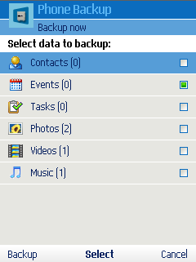
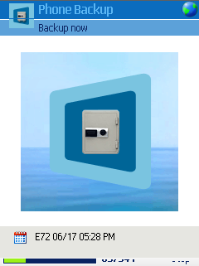
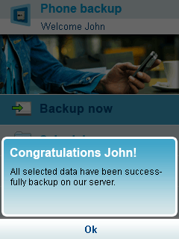

For Java Phones:

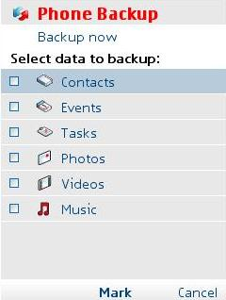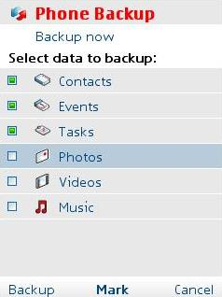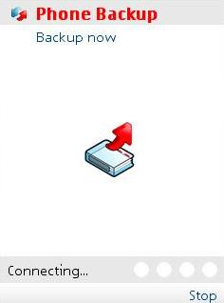

- How can I restore my data from Mobile Phone Backup Web-server using my GPRS (JAVA or Symbian) phone?

You can click on the Phone Backup icon to launch the application as explained in FAQ No. 14. On the screen you will see options of Backup, Schedule, Restore and Settings.

Then click on Restore function on the screen. On the screen you will get option to select which data to restore on to your phone. You will see Contacts, Events, Tasks, Photos, Videos and Music etc depending on the phone model. You can select the data type that you want to restore and click restore to initiate restore process.
The application will prompt you to enter your Password <The password that you use to login to web interface. The application will show you when the selected data has been successfully and securely restored on to your mobile phone.

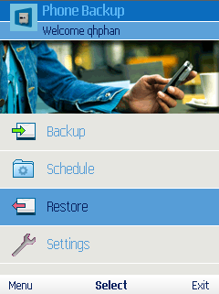

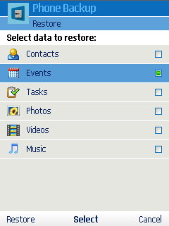
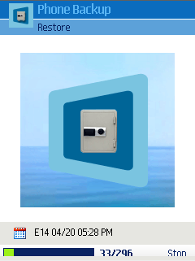
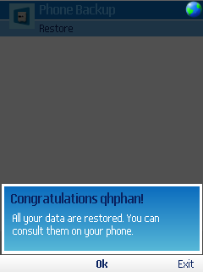

- Can I schedule automatic backup of my GPRS (JAVA or Symbian) phone’s data?

Yes you surely can. You can click on the Phone Backup icon to launch the application as explained in FAQ No. 14. On the screen you will see options of Backup, Schedule, Restore and Settings.

The Schedule option when clicked will show you options of Daily, Weekly, Monthly and keeping the schedule option as ‘OFF’. You can select desired timing and also the desired content that you want to save/backup during the scheduled time. (By default the Schedule option is kept as ‘OFF’ i.e. feature is disabled)

- How will I use a GPRS phone supporting SyncML option to launch the Mobile Phone Backup service?
Please give step-by-step process of receiving settings, what happens in case of Manual settings some representative screenshots for same

When the user clicks on the wap link (operator specific link), it displays the WAP page with the option to send the sync settings to that user. User gets a message with username and password, another message with the link of Phone Backup instruction page. And then an SMS with sync settings which it needs to save into the mobile phone. A new sync profile with Phone Backup is created. Now the user needs to go to options and select Synchronize. This starts the synchronization between the phone and backup server.

In few of the handsets automatic sync settings are not saved. For that we need to create the sync profile manually. When a user select a Motorola V3i on web. The message displayed on the web page is

This phone doesn’t support automatic setup. The next step will walk you through what to do to configure it manually.
Click on the button below to go to the next step.

On the next page, user will get settings of how to create manual sync profile

How to sync from your phone
- 1.Go to the main screen.
- 2.Select Applications, press Options and Open.
- 3.Select Phone Backup, press Options and Open to start the application.
- 4.Press Ok to pass the welcome message.
- 5.Press Yes to agree the Phone Backup Terms & Conditions.
- 6.Check your settings: select Settings in the Options Menu.
In the Account section, enter your Phone Backup login and password, if not already done.
In the Connection section, enter http://PB.BSNL.onmobile.com/bsnlsync/s, if not already done.
- 7.Press Backup now to start your backup.
- 8.Select which data you would like to backup and press OK.
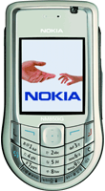
Nokia 6630

- How will I save/backup my phone data using a GPRS (SyncML) phone?

After creating or saving sync profile go to options and select synchronize. This will start synchronization between mobile and phone backup server. The process checks the difference between the phone data and the server data and synchronizes the unavailable data. Through Synchronization backup and restore completes in a single process.

- How will I restore data from the Mobile Phone Backup Web-server using a GPRS (SyncML) phone?

In GPRS (SyncML) phone while synchronization backup and restore completes in a single process. It means both the data will get available at both the server and phone ends.

- How can I schedule an automatic backup from my GPRS (SyncML) phone?

In GPRS (SyncML) process scheduling is not possible as it is not supported by any phone.

- What if my GPRS connectivity breaks at any point while doing Backup or Restore functions?

If the GPRS connectivity breaks at anytime during backup or restore functions then appropriate error message of ‘Network Connection Failed’ will be shown and you will be prompted to ‘Try again’.

In case you exited Phone Backup application without retrying, then the next time that you click on the Phone Backup application, it will automatically show you a message asking you to either resume the earlier transaction or do it later or suspend the transaction permanently. Based on your choice the application will proceed.

- What if I receive a call or SMS while doing backup or restore functions?

If you receive a call or SMS while doing backup or restore functions the backup/restore process is kept on hold temporarily and resumes as soon as the call is completed. However if the call takes too long to complete then an error message ‘Network Connection Failed’ is displayed and you will be prompted to ‘Try again’. Remaining steps are same as given above in FAQ No. 22.

- Can I use the Mobile Phone Backup service if I do not have a GPRS capability Phone?

Yes you can use Mobile Phone Backup Service even if your phone does not support GPRS capability.
You can use SMS as the mode of connecting to the Mobile Phone Backup Web-server to do save/backup and restore of your phone’s data.

- How can I subscribe to the Mobile Phone Backup service if I do not have a GPRS capability Phone?

You can subscribe to the Mobile Phone Backup service by sending a SMS with keyword, ‘SUB to short-code 58989(Toll-free)

- What happens after you get subscribed?

Once you receive the SMS confirming your subscription, you will receive two more messages.

1st SMS has the Internet URL link of your Phone Backup account, the Account User ID, which by default is your phone number in 91xxxxxxxxxx format and the password for web-login. (For details, refer to FAQ No. 31)
2nd SMS will have details (Keyword/SMS Text Syntax) of how to save your Phone contacts using SMS as mode of communication.

- How will I save/backup my phone’s data using SMS?

You can use following two methods to save/backup your phone contacts to the Mobile Phone Backup Web-server:

- Send your contacts as Business Cards to short-code 58989 (Toll-free)
- You can send SMS in format ‘ADD Name1 Phone1, Name2 Phone2,…’ to short-code 58989 (Toll-free)

- How can the user restore the data to his phone?

You can use following two methods to restore the saved/backed-up data to your phone:

- You can restore all the backed up data on to your phone by sending SMS with keyword ‘RESTORE’ to short-code 58989 (Toll-free)
- Individual contacts can be restored by sending SMS with keyword ‘GET Name1, Name2,…’ to short-code 58989 (Toll-free)

- Can I view the data which I saved/backed-up using either my GPRS or non-GPRS phone on to the Mobile Phone Backup Web-server?

Yes, you can access and manage your Mobile Phone Backup service account using your web login details which you have received via SMS.

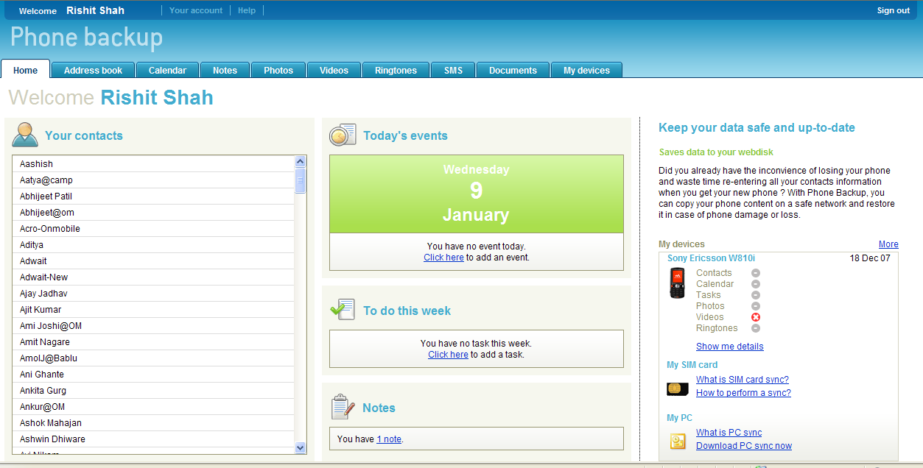

- What will be my Mobile Phone Backup account’s Web-login User ID and Password?

Your phone backup Account User ID will by default be your phone number in 91xxxxxxxxxx format while the initial password is auto-generated by the Mobile Phone Backup Web-server and sent as SMS to you.

- How do I change my Phone backup account password?

Whenever you first log-on to your Mobile Phone Backup account from the internet, this internet account will force you to change the password. You can also change your password after logging into the web account from ‘Your account’ tab.

- What if I forget the password to my Mobile Phone Backup Web-server account?

You can retrieve the password from web interface using forgot password option. The password will be sent by SMS to your mobile phone.

- Why can’t I save/backup or restore after changing my password on Phone Backup Web-server account?

You can’t use any function of the Mobile Phone Backup service after you have changed your password from the Web-login of the Phone backup account, unless you change the password on your phone also.

So please ensure that the password must be changed in both the locations, i.e. Web-account as well as on the mobile phone itself.

- What features are available on the Mobile Phone Backup web-server account?

This will make available your data over the web and you can access or use it when your mobile phone is not available with you. You can completely manage your saved/backed-up data using the phone backup internet account. You can add, delete, edit/modify following:

  - Contacts
  - Events & Tasks
  - Photos
  - Videos
  - SMS

Once these changes are made then you can restore or sync your phone and you will get the updated data from the Mobile Phone Backup service. Even with Web login user can able to send sync settings for their mobile phone.
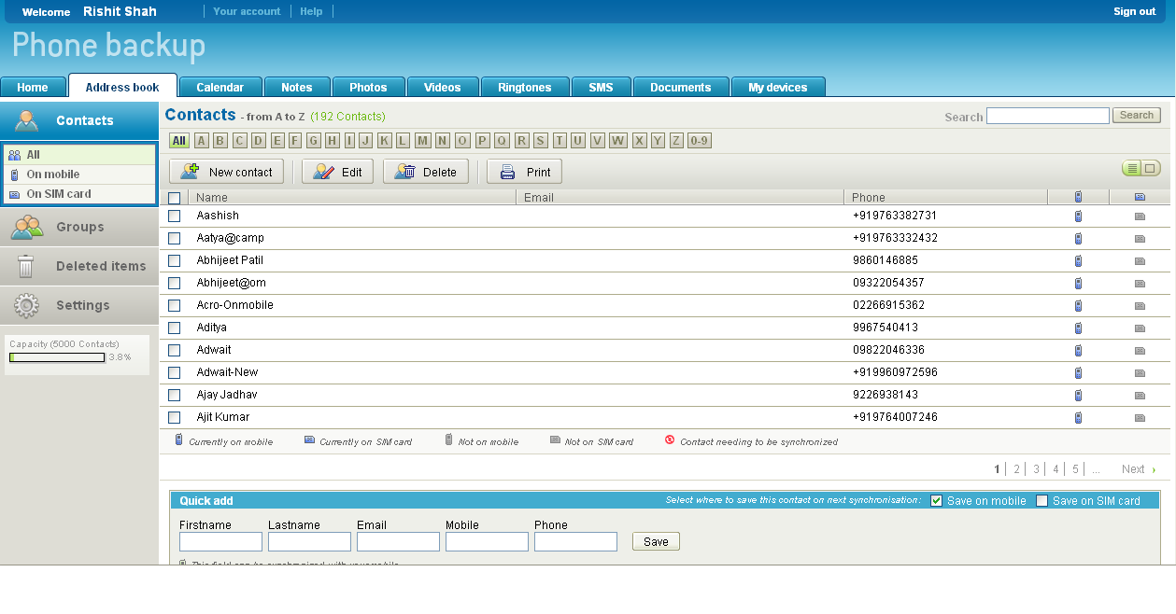

- What happens if I lose my phone or if I change my mobile handset/device?

If you lose your phone do not panic, simply perform a Change Handset/Device action as given below. Similarly in case you buy a new handset/change handset but are using your old SIM (Old Mobile No.), follow the registration and download procedure as mentioned in FAQ No. 10 or FAQ No. 26 as per the GPRS capability of the new mobile handset/device.

When you send SMS with keyword ‘BACKUP’ to short-code(Toll-free) you will receive a ‘Welcome Back’ message with requisite settings.

You can also change your mobile handset/device using the Phone Backup web account.

- How can I unsubscribe and deactivate the Mobile Phone Backup service?

You can unsubscribe/deactivate the Mobile Phone Backup service by:
- Sending a SMS with keyword ‘UNSUB’ to short-code (Toll-free) and then sending a confirmation keyword Yes to short-code after being asked to do so.
- You can call the Customer Care at xxx and get the service deactivated.

- What are the handsets which support the Mobile Phone Backup GPRS client?

Rich Client

Manufacturer | Model
HTC | MTeoR
HTC | S310 (HTC Oxygen)
HTC | S620 (HTC Excalibur 100)
HTC | S710 (HTC Vox)
HTC | Tornado
HTC | Typhoon
HTC | TyTN
HTC iMAte | SP5M (HTC Tornado)
HTC ORANGE | SPV C100 (HTC Oxygen)
HTC ORANGE | SPV C600 (HTC Tornado, HTC Faraday)
HTC ORANGE | SPV C700 (HTC Breeze 160)
HTC ORANGE | SPV M3000 (HTC Wizard 200)
HTC ORANGE | SPV M3100 (HTC Hermes 100)
HTC QTEK | 8310 (HTC Tornado)
HTC QTEK | 8500
HTC T-MOBILE | Dash (HTC Excalibur 160)
HTC T-MOBILE | Wing (HTC Atlas)
HTC VODAFONE | v1240 (HTC Tornado Noble)
HTC VODAFONE | VDA II (HTC Tornado Noble)
Motorola | MPx220
Nokia | 2865i
Nokia | 3155
Nokia | 3155i
Nokia | 3230
Nokia | 5200
Nokia | 5300
Nokia | 6060
Nokia | 6085
Nokia | 6101
Nokia | 6102
Nokia | 6102i
Nokia | 6103
Nokia | 6111
Nokia | 6125
Nokia | 6131
Nokia | 6133
Nokia | 6136
Nokia | 6151
Nokia | 6155
Nokia | 6155i
Nokia | 6230i
Nokia | 6233
Nokia | 6234
Nokia | 6235
Nokia | 6235i
Nokia | 6255
Nokia | 6260
Nokia | 6270
Nokia | 6275i
Nokia | 6280
Nokia | 6288
Nokia | 6300
Nokia | 6600
Nokia | 6620
Nokia | 6630
Nokia | 6670
Nokia | 6680
Nokia | 6681
Nokia | 6682
Nokia | 6822
Nokia | 7360
Nokia | 7370
Nokia | 7373
Nokia | 7390
Nokia | 7610
Nokia | 8800
Nokia | E50
Nokia | E60
Nokia | E61
Nokia | E61i
Nokia | E62
Nokia | E65
Nokia | E70
Nokia | E90
Nokia | N70
Nokia | N71
Nokia | N72
Nokia | N73
Nokia | N75
Nokia | N76
Nokia | N77
Nokia | N80
Nokia | N90
Nokia | N91
Nokia | N92
Nokia | N93
Nokia | N93i
Nokia | N95
Sony Ericsson | K310 / K310i / K310a / K310c
Sony Ericsson | K320 / K320i
Sony Ericsson | K510 / K510i / K510a / K510c
Sony Ericsson | K550 / K550i / K550a / K550c
Sony Ericsson | K600 / K600i / K608i
Sony Ericsson | K610 / K610i / K610c / K618i
Sony Ericsson | K750 / K750i / K750c / D750i
Sony Ericsson | K790 / K790i / K790c / K790a
Sony Ericsson | K800 / K800i / K800c
Sony Ericsson | K810 / K810i
Sony Ericsson | S600 / S600i
Sony Ericsson | V600 / V600i
Sony Ericsson | W200 / W200i
Sony Ericsson | W300 / W300i / W300c
Sony Ericsson | W550 / W550i / W550c
Sony Ericsson | W600 / W600i
Sony Ericsson | W700 / W700i / W700c
Sony Ericsson | W710 / W710i / W710c
Sony Ericsson | W800 / W800i / W800c
Sony Ericsson | W810 / W810i / W810c / W810a
Sony Ericsson | W850 / W850i
Sony Ericsson | W880 / W880i
Sony Ericsson | W900 / W900i
Sony Ericsson | Z300 / Z300i / Z300a
Sony Ericsson | Z310 / Z310i / Z310a
Sony Ericsson | Z520 / Z520i / Z520c / Z520a
Sony Ericsson | Z525 / Z525a
Sony Ericsson | Z530 / Z530i / Z530c
Sony Ericsson | Z550 / Z550i / Z550c
Sony Ericsson | Z610 / Z610i
Sony Ericsson | Z710 / Z710i / Z710c

SyncML

Manufacturer | Model
Ericsson | T68
Motorola | E1 MOTOROKR
Motorola | K1 MOTOKRZR
Motorola | L6 MOTOSLVR
Motorola | L7 MOTOSLVR
Motorola | U9
Motorola | V3 MOTORAZR
Motorola | V360
Motorola | V3i MOTORAZR
Motorola | V3x MOTORAZR
Motorola | V3xx MOTORAZR
Motorola | V500
Motorola | V600
Motorola | V635
Motorola | Z3 MOTORIZR
Nokia | 3220
Nokia | 3230
Nokia | 3250
Nokia | 3300
Nokia | 3595
Nokia | 3600
Nokia | 3620
Nokia | 3650
Nokia | 3660
Nokia | 5140
Nokia | 5200
Nokia | 5300
Nokia | 6010
Nokia | 6020
Nokia | 6021
Nokia | 6080
Nokia | 6085
Nokia | 6086
Nokia | 6101
Nokia | 6102
Nokia | 6102i
Nokia | 6103
Nokia | 6108
Nokia | 6111
Nokia | 6131
Nokia | 6133
Nokia | 6136
Nokia | 6151
Nokia | 6170
Nokia | 6200
Nokia | 6220
Nokia | 6230
Nokia | 6230i
Nokia | 6233
Nokia | 6234
Nokia | 6260
Nokia | 6270
Nokia | 6275i
Nokia | 6280
Nokia | 6288
Nokia | 6300
Nokia | 6600
Nokia | 6610i
Nokia | 6620
Nokia | 6630
Nokia | 6670
Nokia | 6680
Nokia | 6681
Nokia | 6682
Nokia | 6800
Nokia | 6810
Nokia | 6820
Nokia | 6822
Nokia | 7250
Nokia | 7250i
Nokia | 7280
Nokia | 7360
Nokia | 7370
Nokia | 7373
Nokia | 9210
Nokia | 9300 / 9300i
Nokia | 9500
Nokia | E50
Nokia | E61
Nokia | E70
Nokia | N70
Nokia | N71
Nokia | N72
Nokia | N73
Nokia | N75
Nokia | N76
Nokia | N80
Nokia | N90
Nokia | N91
Nokia | N93
Nokia | N93i
Nokia | N95
Nokia | N-Gage & N-Gage QD
Panasonic | VS3
Panasonic | X70
Panasonic | X701
Samsung | SGH-T219
Samsung | SGH-T409
Samsung | SGH-T419
Samsung | SGH-T429
Samsung | SGH-T519
Samsung | SGH-T539
Samsung | SGH-T619
Samsung | SGH-T629
Samsung | SGH-T649
Samsung | SGH-T729
Samsung | SGH-T739
Sanyo | S750 / S750i
Siemens | C65
Siemens | CF62
Siemens | CX65
Siemens | M65
Siemens | S65
Sony Ericsson | F500 / F500i
Sony Ericsson | K300 / K300i / K300c / K300a
Sony Ericsson | K310 / K310i / K310a / K310c
Sony Ericsson | K320 / K320i
Sony Ericsson | K500 / K500i / K506c / K508i / K508c
Sony Ericsson | K600 / K600i / K608i
Sony Ericsson | K610 / K610i / K610c / K618i
Sony Ericsson | K700 / K700i / K700c
Sony Ericsson | K750 / K750i / K750c / D750i
Sony Ericsson | K800 / K800i / K800c
Sony Ericsson | P800
Sony Ericsson | P900
Sony Ericsson | P910 / P910i
Sony Ericsson | S600 / S600i
Sony Ericsson | S700 / S700i / S700c / S710a
Sony Ericsson | S710a
Sony Ericsson | T610 / T610i
Sony Ericsson | T616
Sony Ericsson | T62u
Sony Ericsson | T630
Sony Ericsson | T637
Sony Ericsson | T68i
Sony Ericsson | T68ie / T68m
Sony Ericsson | V600 / V600i
Sony Ericsson | V630
Sony Ericsson | V800 / V800i / Vodafone 802SE
Sony Ericsson | W200 / W200i
Sony Ericsson | W300 / W300i / W300c
Sony Ericsson | W550 / W550i / W550c
Sony Ericsson | W600 / W600i
Sony Ericsson | W710 / W710i / W710c
Sony Ericsson | W800 / W800i / W800c
Sony Ericsson | W810 / W810i / W810c / W810a
Sony Ericsson | W850 / W850i
Sony Ericsson | W900 / W900i
Sony Ericsson | Z1010
Sony Ericsson | Z500 / Z500a
Sony Ericsson | Z520 / Z520i / Z520c / Z520a
Sony Ericsson | Z600
Sony Ericsson | Z610 / Z610i
Sony Ericsson | Z800 / Z800i

- I am unable to access the Mobile Phone Backup service. What all settings should I check on the mobile handset?

The following service settings you need to check:

- GPRS (JAVA & Symbian) Rich Client Users:
  - Check the Subscription Status, whether Active, or Deactivated
  - Check whether your GPRS service, is working properly or not
  - Check for the Client Settings

- SyncML Users:
  - Check the Subscription Status, whether Active, or Deactivated
  - Check whether your phone’s GPRS service, is working properly or not.
  - Check for the Sync ML Settings

- Non-GPRS/ SMS Users:
- Check for your Subscription Status, whether Active, or Deactivated

- How is my subscription renewed?

When your subscription period of one month gets over the Mobile Phone Backup system checks for the pre-paid balance in the your Mobile Account and on receipt of subscription fee extends the subscription for a period of one month.
If there are issues of insufficient balance in your mobile’s pre-paid account then the system keeps trying for next three days. During this period your Phone Backup account will be suspended. After three days if subscription confirmation is not received by the Mobile Phone Backup due to insufficient balance the service gets deactivated automatically.

In case you have a post-paid mobile connection, then automatically on expiry of a month’s time after subscription date, the Mobile Phone Backup service is renewed.

