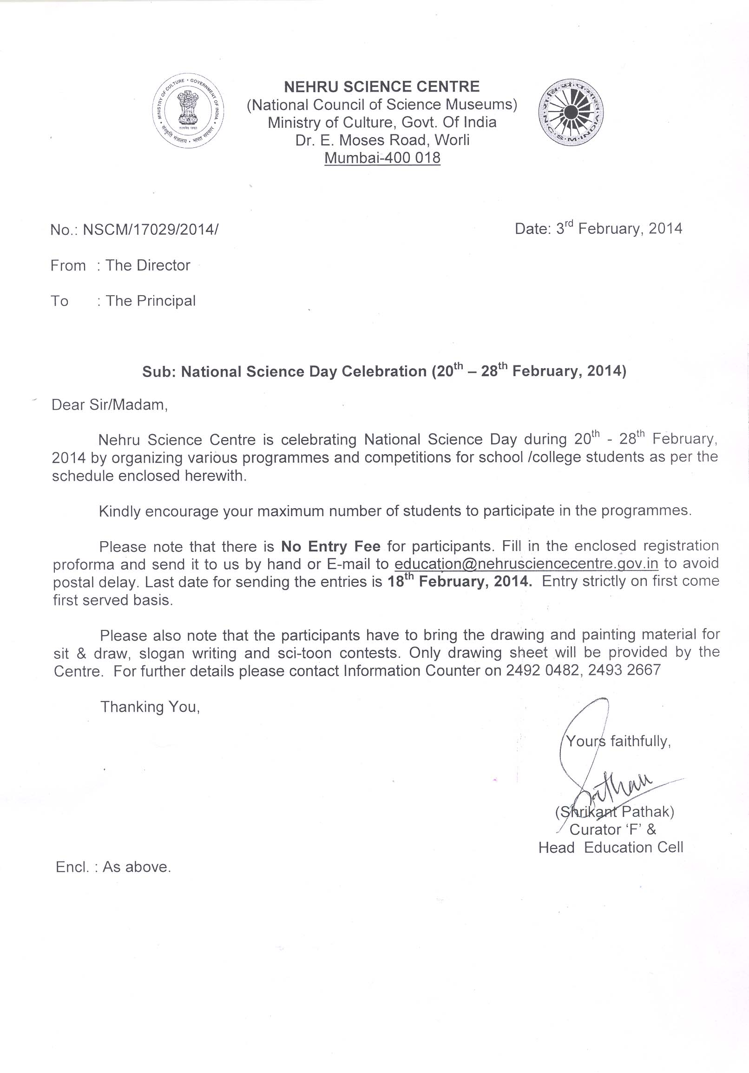

NEHRU SCIENCE CENTRE, MUMBAI

INVITES YOUR SCHOOL/COLLEGE FOR
National Science Day Celebration
(February 20th – 28th, 2014)

PARTICIPATE IN THE PROGRAMMES AND WIN FABULOUS PRIZES
S.N. | Programme / Contest | Date & Time | Particulars
1. | Workshop on Vedic mathematics  by Dr. Devang Shah  Collaborator: Leo Club of Vidyavihar | 20.02.2014  (Thursday)  10.30 a.m. to 12.30 p.m. | - For students from Std. 8th to 10th  - Maximum 50 students from a school
2. | Workshop on Aero modelling Techniques by Shri Dilshad Ahmed  Collaborator: Leo Club of Vidyavihar | 20.02.2014  (Thursday)  2.30 p.m. to 4.30 p.m. | - For students from Std. 8th to 12th  - Maximum 5 students from a school/college
3. | Workshop on Human Computers  by Dr. Devang Shah  Collaborator: Leo Club of Vidyavihar | 21.02.2014  (Friday)  10.30 a.m. to 12.30 p.m. | - For students from Std. 8th to 12th  - Maximum 50 students from a school/college
4. | Workshop on Cyber Crime Awareness  by Adv. Manish Kenia & Adv.Vicky Shah Collaborator: Leo Club of Vidyavihar | 21.02.2014  (Friday)  2.30 p.m. to 4.30 p.m. | - For students from Std. 8th to 12th  - Maximum 50 students from a school/college
5. | Science Slogan Writing Contest  Topic: Fostering Scientific Temper for  Human Welfare | 22.02.2014  (Saturday)  11.00 a.m. to 12.00 noon | - For students from Std. 8th to 10th  - Maximum 20 students from a school  - 5 prizes
6. | Sci-toon Contest  (Draw a Science Cartoon)  Topic: Fostering Scientific Temper | 22.02. 2014  (Saturday)  11.00 a.m. to 1.00 p.m. | - For students from Std. 8th to 10th  - Maximum 20 students from a school  - 5 prizes
7. | Popular Science Lecture  by Dr. Sunder  Bhabha Atomic Research Centre, Mumbai  Topic: The Invisible Universe | 22.02.2014  (Saturday)  11.30 a.m. to 1.00 p.m. | - For students from Std. 8th & above  - Maximum 50 students from a school/college
8. | Sit & Draw Contest  Topic:  Cat A: Visit to Science Park  Cat B: Water Conservation  Cat C: Science & Technology for Human Welfare | 23.02.2014  (Sunday)  11.00 a.m. to 1.00 p.m. | - Three categories  - Category A: Up to Std. 4  - Category B: Std. 5th to 7th  - Category C: Std 8th to 10th  - Max. 20 students in each category  - 5 prizes in each category
9. | Popular Science Lecture  by Prof. Sumant Rao  Innovation Design Centre, IIT Bombay  Topic: Technology & Animation | 24.02.2014  (Monday)  11.30 a.m. to 1.00 p.m. | - For students from Std. 8th & above  - Maximum 50 students from a school/college
10. | Inter-School written Science Quiz Contest  Topic: Science and Technology | 24.02.2014  (Monday)  2.30 p.m. to 3.30 p.m. | - For students from Std. 7th to 9th  - Maximum 5 students from a school
11. | Popular Science Lecture  by Prof. Shubha Tole  Dept. of Biological Sciences, TIFR, Mumbai  Topic: Ande ka Fanda | 26.02.2014  (Wednesday)  11.30 a.m. to 1.00 p.m. | - For students from Std. 8th & above  - Maximum 50 students from a school/college
12. | Elocution competition  Topic: Fostering Scientific Temper-Need of the Hour | 27.02.2014  (Thursday)  11.30 a.m. | - For students from Std. 8th to 10th  - One student from a school  - Duration for speech : Maximum 3 Min.  - 5 prizes
13. | Science shows /Science Demonstration Lecture | 20.02.2014 to 28.02.2014  Daily at 12.00, 2.00 p.m. and 4.00 p.m. | - Open to all  - Maximum 50 students from a school  - Please book in advance
14. | Sky Observation through telescope | 22.02.2014 to 28.02.2014  6.00 p.m. to 7.15 p.m. | - Open to all  - Please book in advance  - Report at the centre by 6 p.m.
15. | Sir C.V. Raman Memorial Lecture  Prize distribution & Valediction | 28.02.2014  (Friday)  11.30 a.m. | - For students from Std. 8th & above  - Maximum 50 students from a school/college

NO ENTRY FEE
Fill in the enclosed proforma and send it to us by hand or E-mail to education@nehrusciencecentre.gov.in to avoid postal delay. Last date: 18th February 2014. Entry strictly on first come first served basis. For further details, please contact Information Counter on 2492 0482.
Organized by
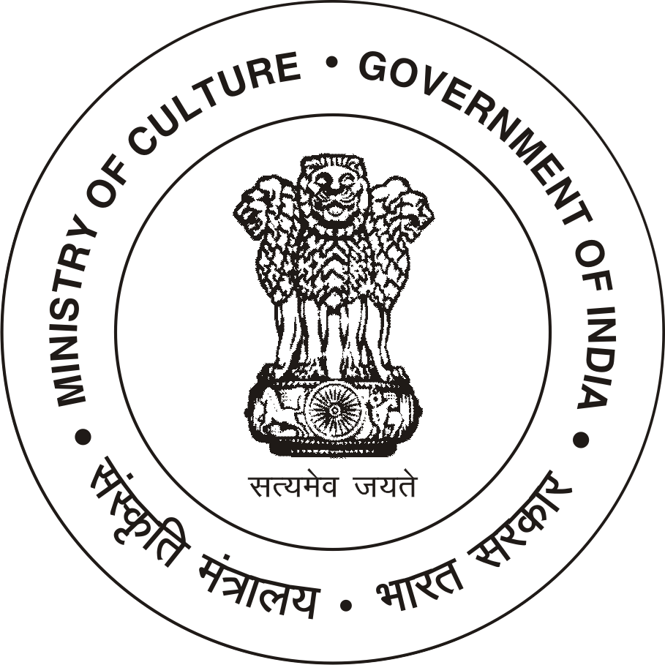
NEHRU SCIENCE CENTRE
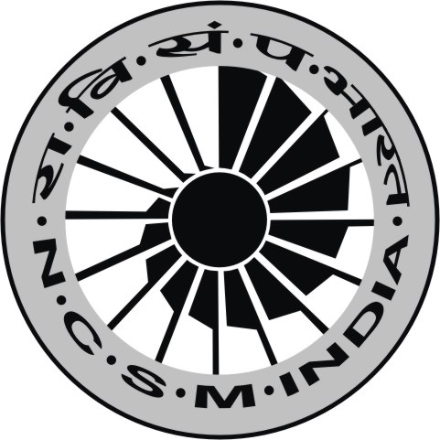

(National Council of Science Museums)
Ministry of Culture, Govt. of India
Dr. E. Moses Road, Worli, Mumbai-400 018
Phone :24920482/ 2493 2667 FAX : 2492 6042.
E-mail: education@nehrusciencecentre.gov.in
Website: www.nehrusciencecentre.gov.in
----------------------------------------Catalyzed and Supported by---------------------------------------------
National Council for Science and Technology Communication, DST, Govt. of India
Rajiv Gandhi Science and Technology Commission, Govt. of Maharashtra

NEHRU SCIENCE CENTRE
(National Council of Science Museums)

Dr. E. Moses Road, Worli, Mumbai-400 018

National Science Day Celebration 2014

REGISTRATION FORM

- Name of the School & Address : __________________________________________________ _________________________________________________________________________________
2. Name of the contact person : _______________________________ Phone :__________________

To: The Director
Nehru Science Centre,
Dr. E. Moses Road, Worli, Mumbai

Sir,

We are interested to send the following number of students for various programmes and competitions that are
being organized at your Centre during National Science Day Celebration from 20th – 28th February, 2014.

S.N. | Programme / Contest | Date & Time | No. of Students/ Teachers
1. | Workshop on Vedic mathematics  by Dr. Devang Shah | 20.02.2014 (Thursday)  10.30 a.m. to 12.30 p.m.  Max. 50 students from a school
2. | Workshop on Aero modelling Techniques  by Shri Dilshad Ahmed | 20.02.2014 (Thursday)  2.30 p.m. to 4.30 p.m.  Max. 5 students from a school/college
3. | Workshop on Human Computers  by Dr. Devang Shah | 21.02.2014 (Friday)  10.30 a.m. to 12.30 p.m.  Max. 50 students from a school/college
4. | Workshop on Cyber Crime Awareness  by Adv. Manish Kenia & Adv. Vicky Shah | 21.02.2014 (Friday)  2.30 p.m. to 4.30 p.m.  Max. 50 students from a school/college
5. | Science Slogan Writing Contest  Topic: Fostering Scientific Temper for  Human Welfare | 22.02.2014 (Saturday)  11.00 a.m. to 12.00 noon  Max. 20 students from a school
6. | Sci-toon Contest  (Draw a Science Cartoon)  Topic: Fostering Scientific Temper | 22.02. 2014(Saturday)  11.00 a.m. to 1.00 p.m.  Max. 20 students from a school
7. | Popular Science Lecture  by Dr. Sunder  Bhabha Atomic Research Centre, Mumbai  Topic: The Invisible Universe | 22.02.2014(Saturday)  11.30 a.m. to 1.00 p.m.  Maximum 50 students from a school/college
8. | Sit & Draw Contest  Category A: Up to Std. 4 | 23.02.2014(Sunday)  11.00 a.m. to 1.00 p.m.  School can depute max. 20 students in each Category
8. | Sit & Draw Contest  Category B: Std. 5th to 7th
8. | Sit & Draw Contest  Category C: Std 8th to 10th
9. | Popular Science Lecture  by Prof. Sumant Rao  Innovation Design Centre, IIT Bombay  Topic: Technology & Animation | 24.02.2014(Monday)  11.30 a.m. to 1.00 p.m.  Maximum 50 students from a school/college
10. | Inter-School Written Science Quiz Contest  Topic: Science and Technology | 24.02.2014(Monday)  2.30 p.m. to 3.30 p.m.  Max. 5 students from a school
11. | Popular Science Lecture  by Prof. Shubha Tole  Dept. of Biological Sciences, TIFR, Mumbai  Topic: Ande ka Fanda | 26.02.2014 (Wednesday)  11.30 a.m. to 1.00 p.m.  Maximum 50 students from a school/college
12. | Elocution competition  Topic: Fostering Scientific Temper-Need of the  Hour | 27.02.2014 (Thursday)  11.30 a.m.  1 student from a school
13. | Science shows / Science Demonstration Lecture  (Maximum 50 students from a School /College)  Prior booking of time slot required) | 20.02.2014 to 28.02.2014  Daily at 12.00, 2.00 p.m. and 4.00 p.m. | Date:__________  Time: _________  No. of students:________
14. | Sky Observation through telescope | 22.02.2014 to 28.02.2014  6.00 p.m. to 7.15 p.m. | Date:__________  No. of students:________
15. | Sir C.V. Raman Memorial Lecture  Prize distribution & Valediction | 28.02.2014 (Friday)  11.30 a.m.  Maximum 50 students from a School / College

Thanking you,

Date : ( Principal)
Seal of the Institution

